Sorte G
v0.1.0 Industrial Systems
Table of Contents
Document History 2
Sorte G 3
TMDS64GPEVM 3
Device system 3
Controller system 3
Test results 4
Test setup 1: 4
Default EVM 4
Programmed registers 4
IMPORTANT NOTICE AND DISCLAIMER 5

Document History
Version | Date | Notes
0.1 | Mar 2023 | First version [KNM]

Sorte G

TMDS64GPEVM – setup
Using the TMDS64GPEVM you need to power it with a 12V power supply and have a prepared SD-card which include the MLO(bootloader) and app(Sorte G application code).
The board can be seen in the following image.
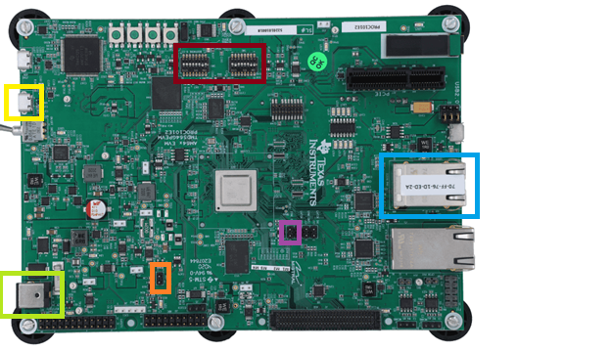
Blue box: SORTE G is running on the RJ45 connector
Orange box: Selection header(J12) for choosing if SORTE G is running in Controller(Not connected) or Device mode(Jumper connected).
Yellow box: Virtual com port connection which provide a terminal GUI on PC to enable and reset the example code.
Purple box: Header with signals showing the synchronization of different controller and devices in the system, here ICSS1_SYNC0 is used which is on J18
Red box: Switches which define which boot mode is selected.
Green box: Power supply, here be aware the ball connector is not the standard (5.5mm x 2.1mm x 9.5mm Barrel Jack.) need to ensure this is connected with the right connector, if this is not done the board may get damaged. To avoid this the following connector can also be used as a inbetween connector (DC PLUG-P1J-P1M).
When running the GPEVM for the SORTE G demo there are two boot modes which are important one is the JTAG boot mode and one is the SD-card boot mode. Below it can be seen what the setting of the switches are for each mode. For more information on this function please look in the user guide of the GPEVM.
JTAG boot Mode | SD card boot mode
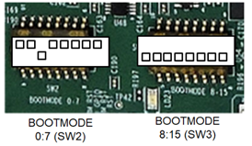 | 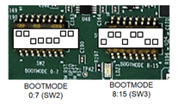

Running the application on 2 or 3 TMDS64GPEVMs is needed here one board is setup as controller and two boards as device.
The demo is running from an SD-card and the explained boot mode is picked, this will enable to AM64x to run the app code on the SD-card, this app is running on the ARM R5 core.
To start the demo the virtual com port has to be used here used systems has to be connected through it.
To setup this connection a terminal GUI can be used link putty, in this GUI the following settings needs to be used for the serial interface.
Virtual com port serial connection | Virtual com ports shown connecting TMDS64GPEVM
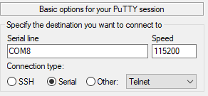 | 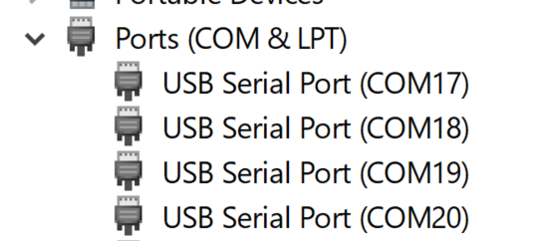

When this is done the following images can be seen.

Terminal gui of the controller app, which is based on J12 setting
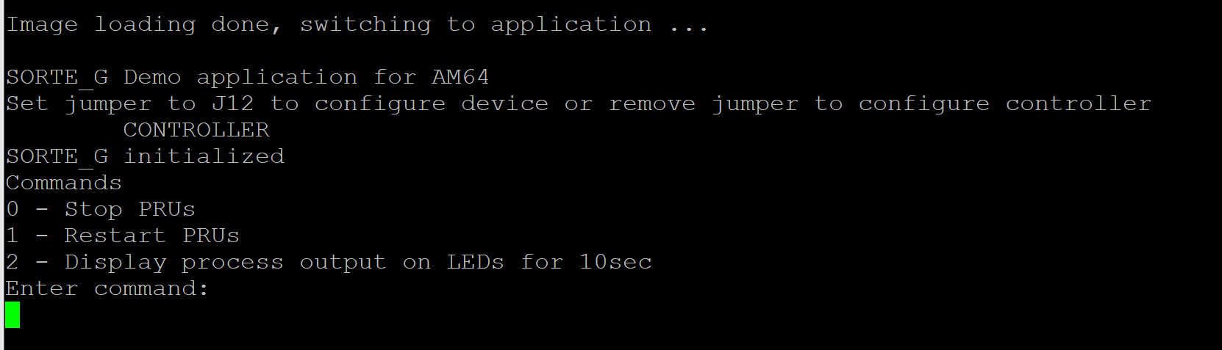
Terminal gui of the drive app, which is based on J12 setting
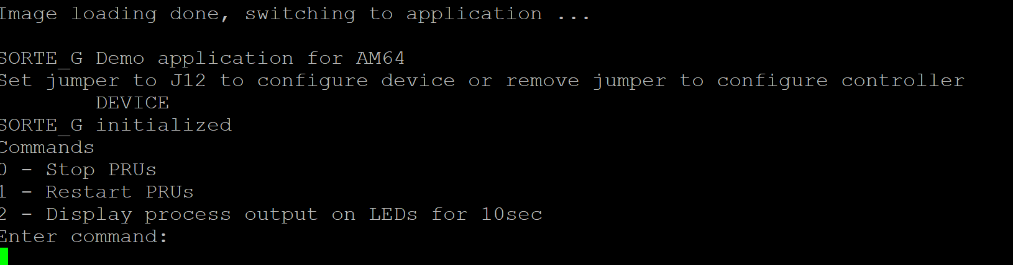

Also here the Virtual com port drive is based on the first com port definition of he board as see above.
For the example test setup 1 controller and 2 devices are used, below you can see how they are connected over the RJ45 connector.
Figure 3: Picture of test setup using the three3 TMDS64GPEVMs one controller and two devices
RJ connectors used
RJ connector of controller | RJ connector of device 1 | RJ connector of device 2

The LEDs blinking in the demo is showing the received data payload of the controller to device or the response back to the controller transmitted from the device.

Device system
Currently the following can be seen on Client ICSS_G1_PRU0
0x2000 is the payload on the transmitted data
0x2040 is payload of the received data
When updating the code it is needed to ensure that the PHY address is passed correctly as it is used to see if the link is ready to transmit.

Controller system
When updating the code it is needed to ensure that the PHY address is passed correctly as it is used to see if the link is ready to transmit.
Controller: 0x800
This is the address of the received data on the controller or client board.

Programmed registers

Test results

Test setup 1:

Figure 2: Block diagram of test setup using the three TMDS64GPEVMs one controller and two devices
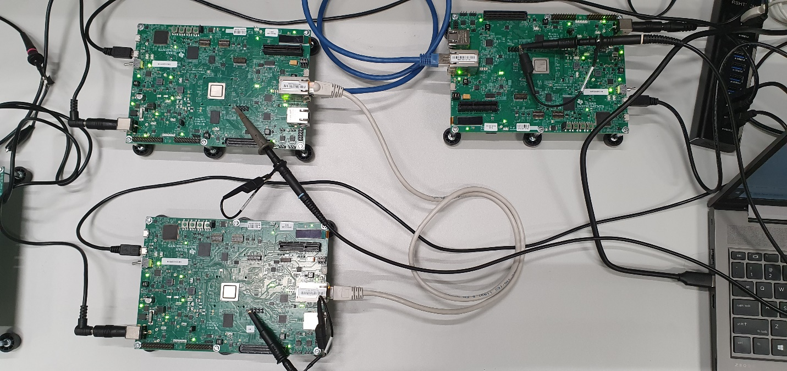
Figure 3: Picture of test setup using the three3 TMDS64GPEVMs one controller and two devices

Sync out signal test
Below the test result of measuring the sync out pin of the 1 controller 2 devices can be seen, this is measured on pin J18 see image below
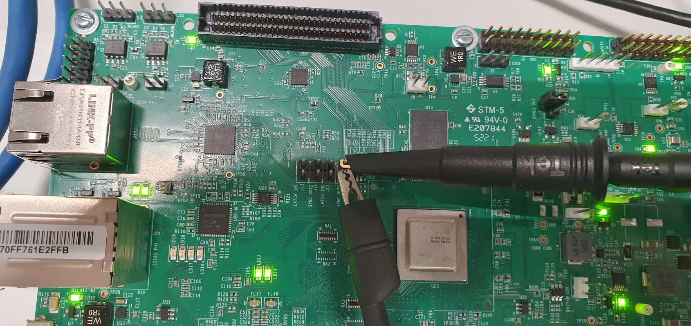
Figure 3: Probe connection for sync out measurement this is done on all boards used in the system

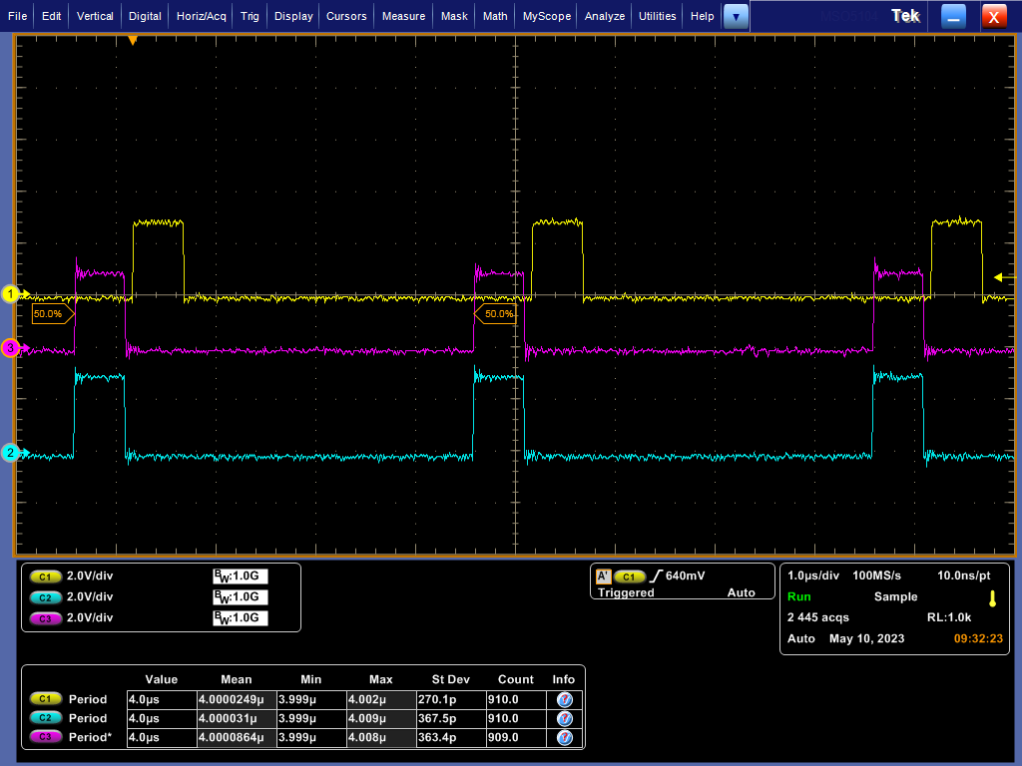
Figure 3: Measurement of sync out pin to see the data
Yellow is Controller
Blue is first device
Pink is second device

IMPORTANT NOTICE AND DISCLAIMER
TI PROVIDES TECHNICAL AND RELIABILITY DATA (INCLUDING DATASHEETS), DESIGN RESOURCES (INCLUDING REFERENCE DESIGNS), APPLICATION OR OTHER DESIGN ADVICE, WEB TOOLS, SAFETY INFORMATION, AND OTHER RESOURCES “AS IS” AND WITH ALL FAULTS, AND DISCLAIMS ALL WARRANTIES, EXPRESS AND IMPLIED, INCLUDING WITHOUT LIMITATION ANY IMPLIED WARRANTIES OF MERCHANTABILITY, FITNESS FOR A PARTICULAR PURPOSE OR NON-INFRINGEMENT OF THIRD PARTY INTELLECTUAL PROPERTY RIGHTS.
These resources are intended for skilled developers designing with TI products. You are solely responsible for (1) selecting the appropriate TI products for your application, (2) designing, validating and testing your application, and (3) ensuring your application meets applicable standards, and any other safety, security, or other requirements.
These resources are subject to change without notice. TI grants you permission to use these resources only for development of an application that uses the TI products described in the resource. Other reproduction and display of these resources is prohibited. No license is granted to any other TI intellectual property right or to any third party intellectual property right. TI disclaims responsibility for, and you will fully indemnify TI and its representatives against, any claims, damages, costs, losses, and liabilities arising out of your use of these resources.
TI’s products are provided subject to TI’s Terms of Sale (www.ti.com/legal/termsofsale) or other applicable terms available either on ti.com or provided in conjunction with such TI products. TI’s provision of these resources does not expand or otherwise alter TI’s applicable warranties or warranty disclaimers for TI products.

Copyright © 2021, Texas Instruments Incorporated

